**Adidas Sales Database PowerBI Dashboard Report**

* **Introduction :-**

**Dataset:- Dataset contains Adidas Sales Data StateWise,RegionWise,CityWise of Different Product Sold through Different SalesMethod(i.e. Online,In-store,Outlet through different retailer(i.e. Amazon,Foot Locker etc).**

**Objective :- Through Dashboard Creation we can easily analyse data which region has less sales and which have good sales of which product and which retailer is suitable or performing better for which state etc.**

**Question:-**

* **Find Total Sales, Total Unit Sold, Total Profit & Total Expense (through adding column) – Using Card**
* **Find Sales by Method,Sales by Region, Sales by Retailer - Using Donut Chart**
* **Find Year on Year Profit And Sales Using Area Chart**
* **Find Total Sales by Product Using Bar Chart.**
* **Use Filter for Drilldown to represt State & City and Use Map to Represent StateWise Sales.**
* **Forecast Sales for Next 6 Months.**

* **Data Pre-Processing and Cleaning :-**

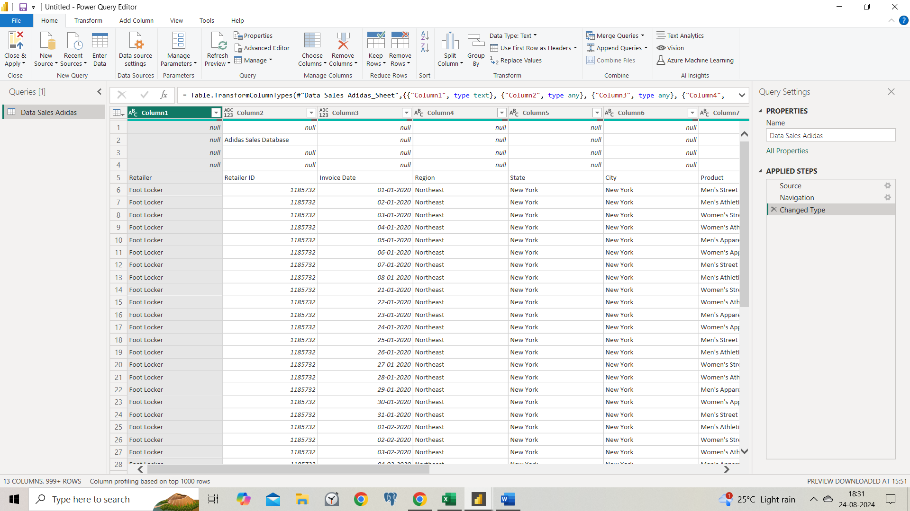

* **Removing Null Values and Shift Row5th as Header.**
* **Changing Numeric DataTypes to $(Currency) of Columns such as Price,TotalSales,Operating profit.**
* **Changing Operating Margin Column DataType to Percentage.**

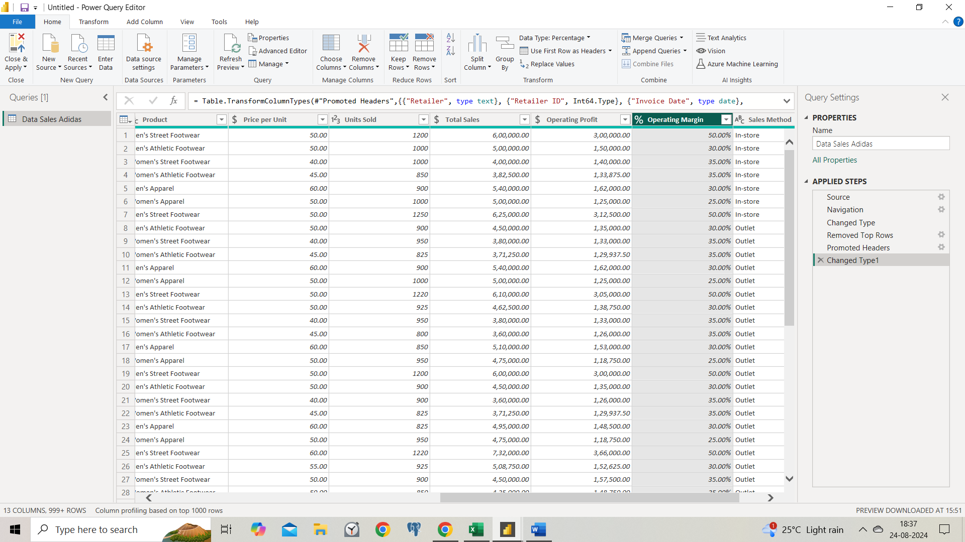

* **Adding Column Name Operating Exepnse using DAX Function ie. [Total Sales] – [Operating Profit]**

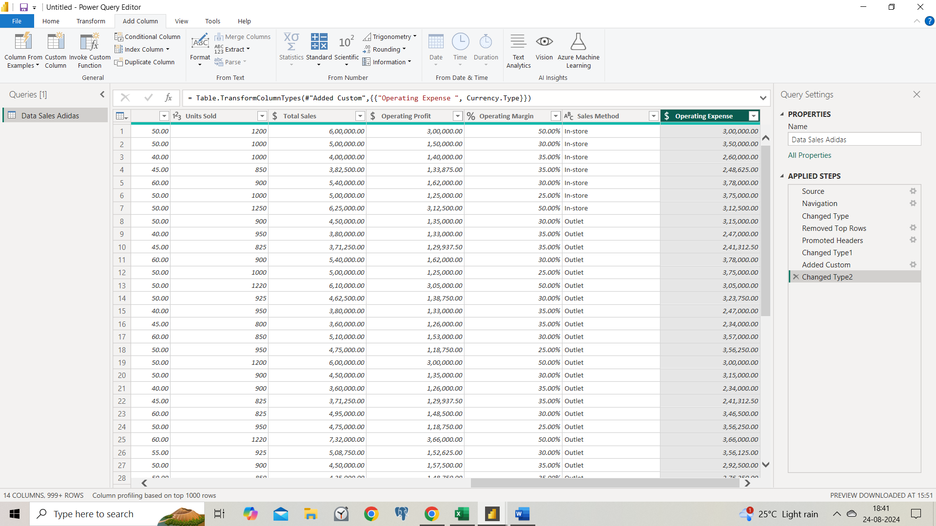

* **Dashboard:**

**Set the canavs background for attractive presentation**

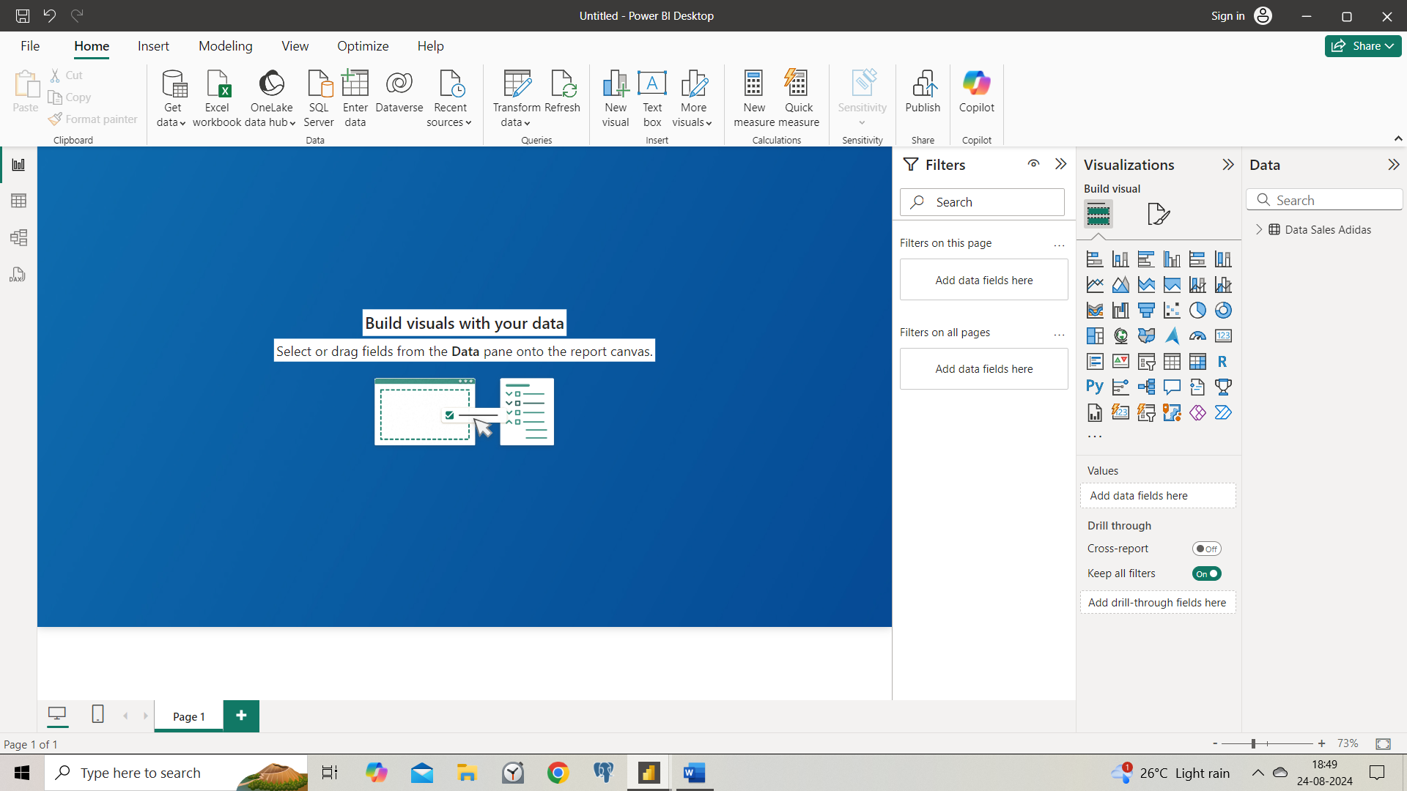

* **Set the Title using Text box**
* **Find Total Sales, Total Unit Sold, Total Profit & Total Expense (through adding column) – Using Card and set the Format Accordingly of one and then with the help of format painter set for others.**

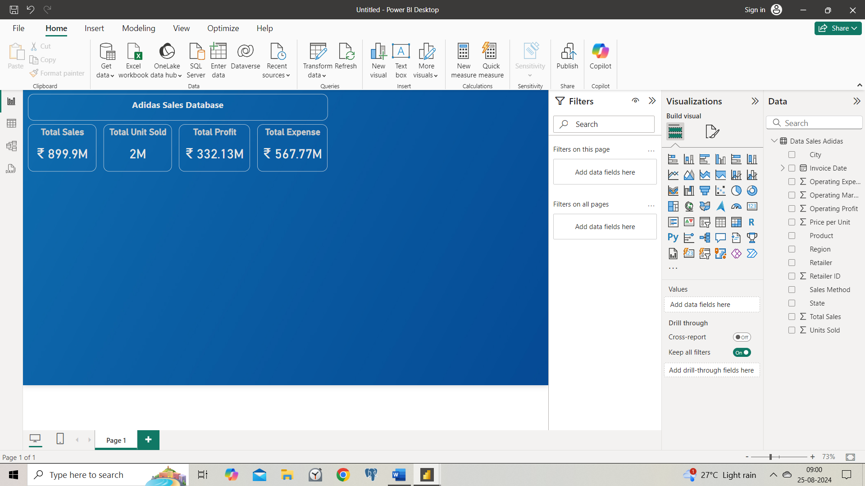

* **Find Sales by Method,Sales by Region, Sales by Retailer - Using Donut Chart and similarly format the one and apply using format painter in others.**

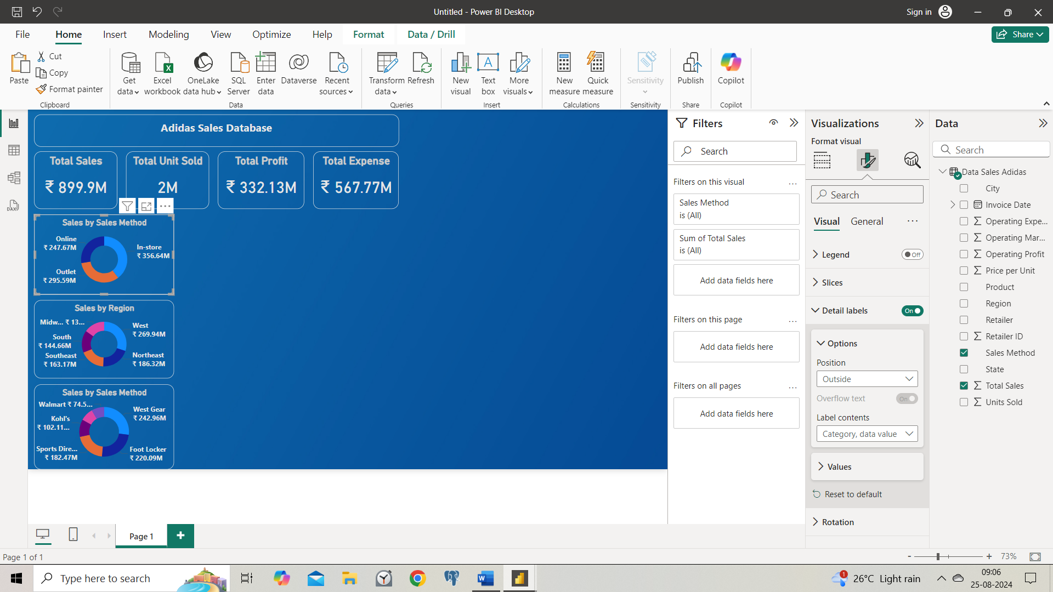

* **Find Year on Year Profit And Sales Using Stacked Area Chart**

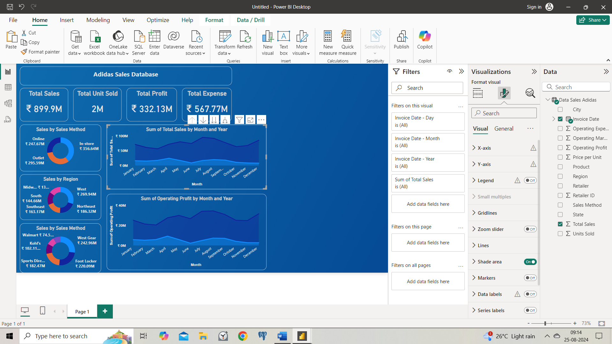

* **Find Total Sales by Product Using Bar Chart.**

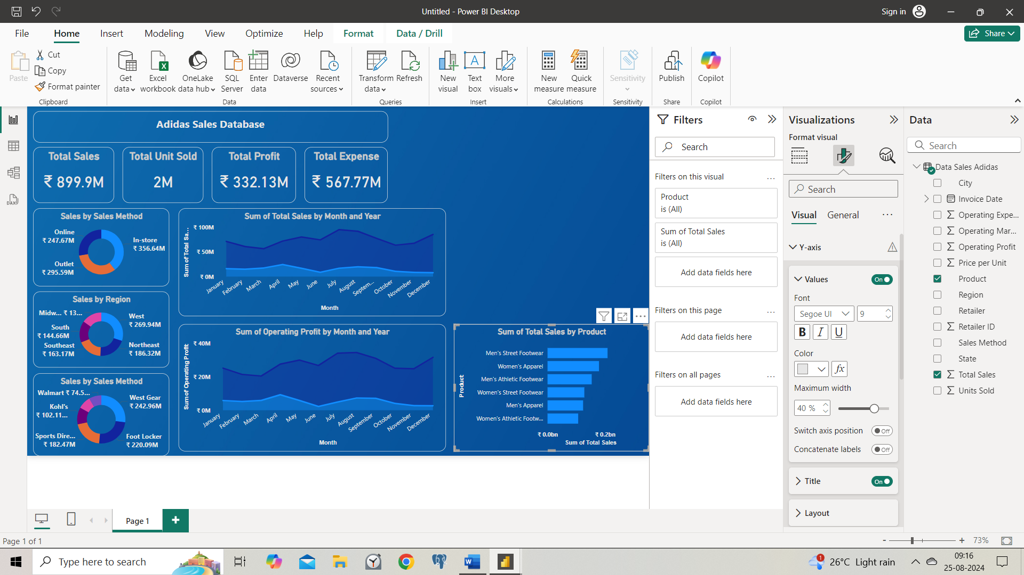

* **Use Filter Drilldown to represt State & City to easily select and analyse the data for respective city and state.**

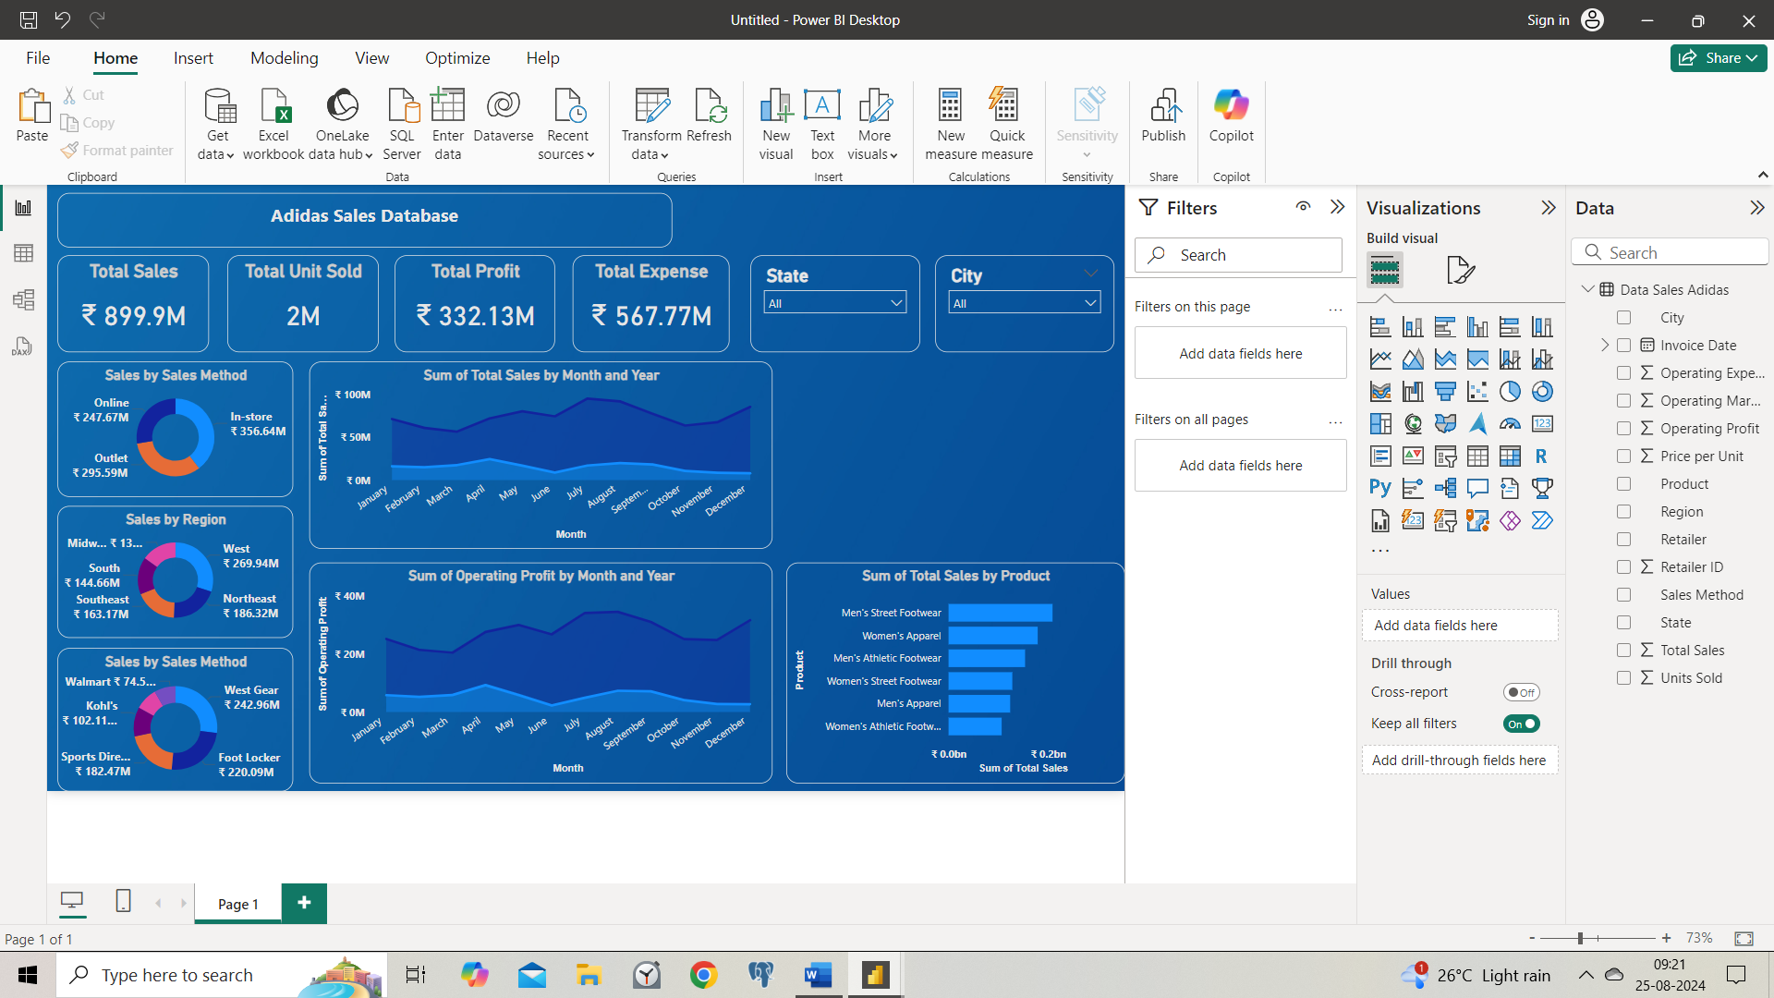

* **Use Filter Tile to represent Region to easily select and analyse the data for respective Regions.**

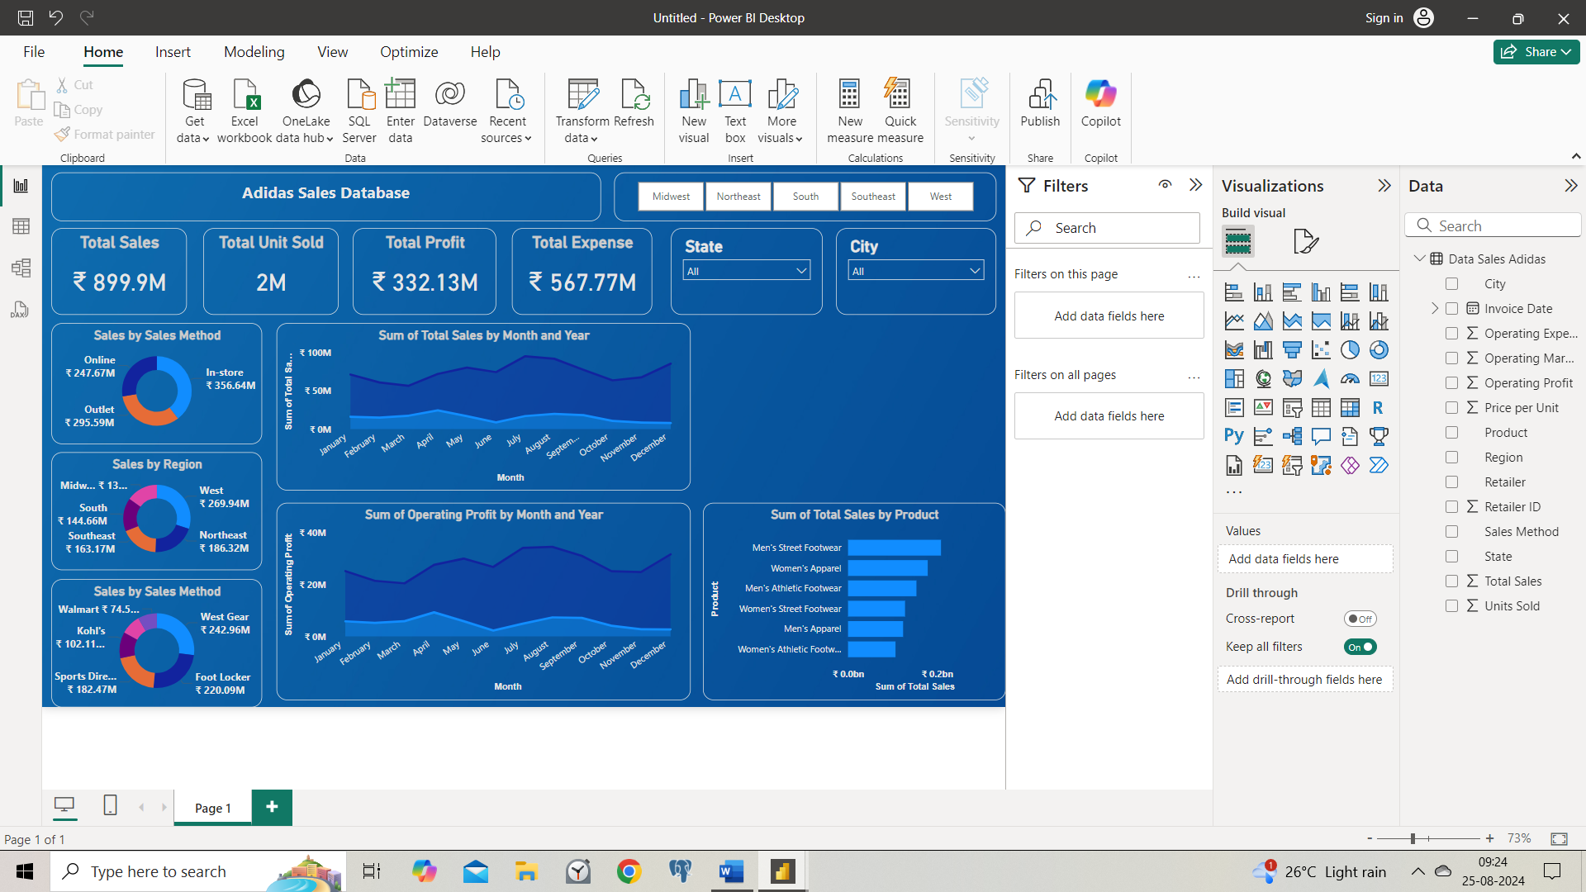

* **Use Map to Represent StateWise Total Sales, Operating Profit And Operating Expense.**

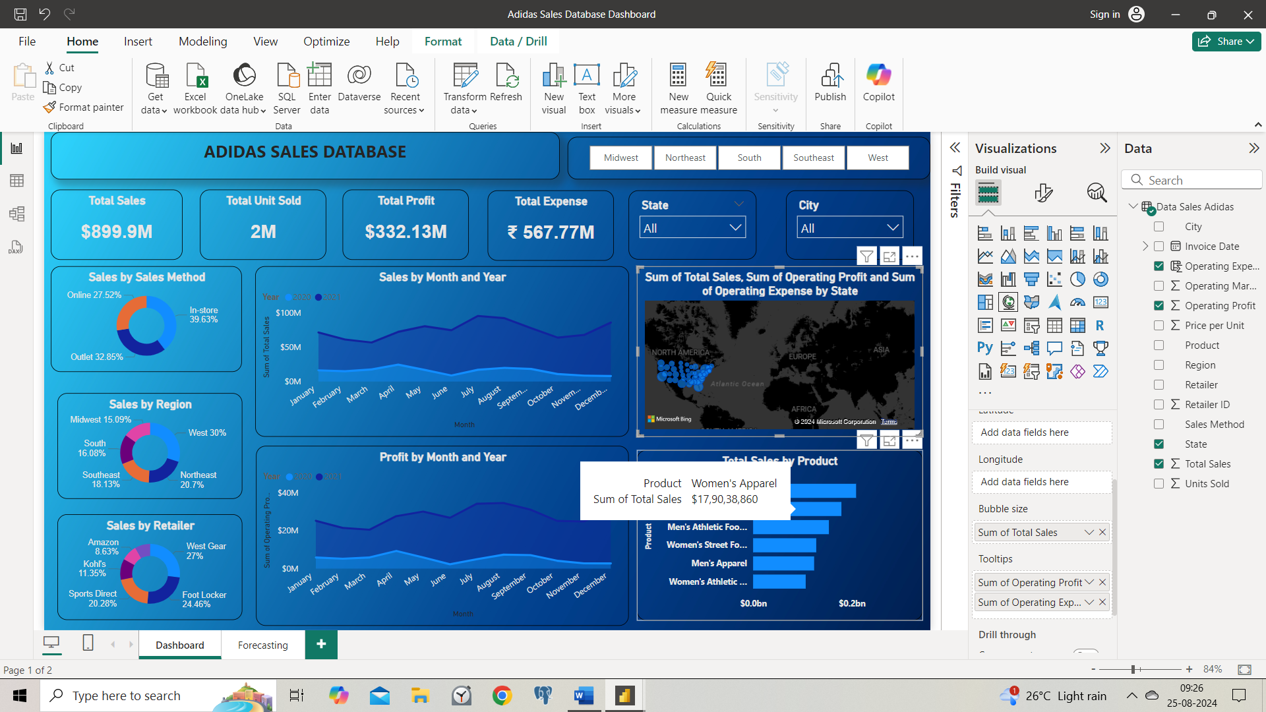

* **Forecast Unit Sold for Next 6 Months in New Sheet Using Slicer.**

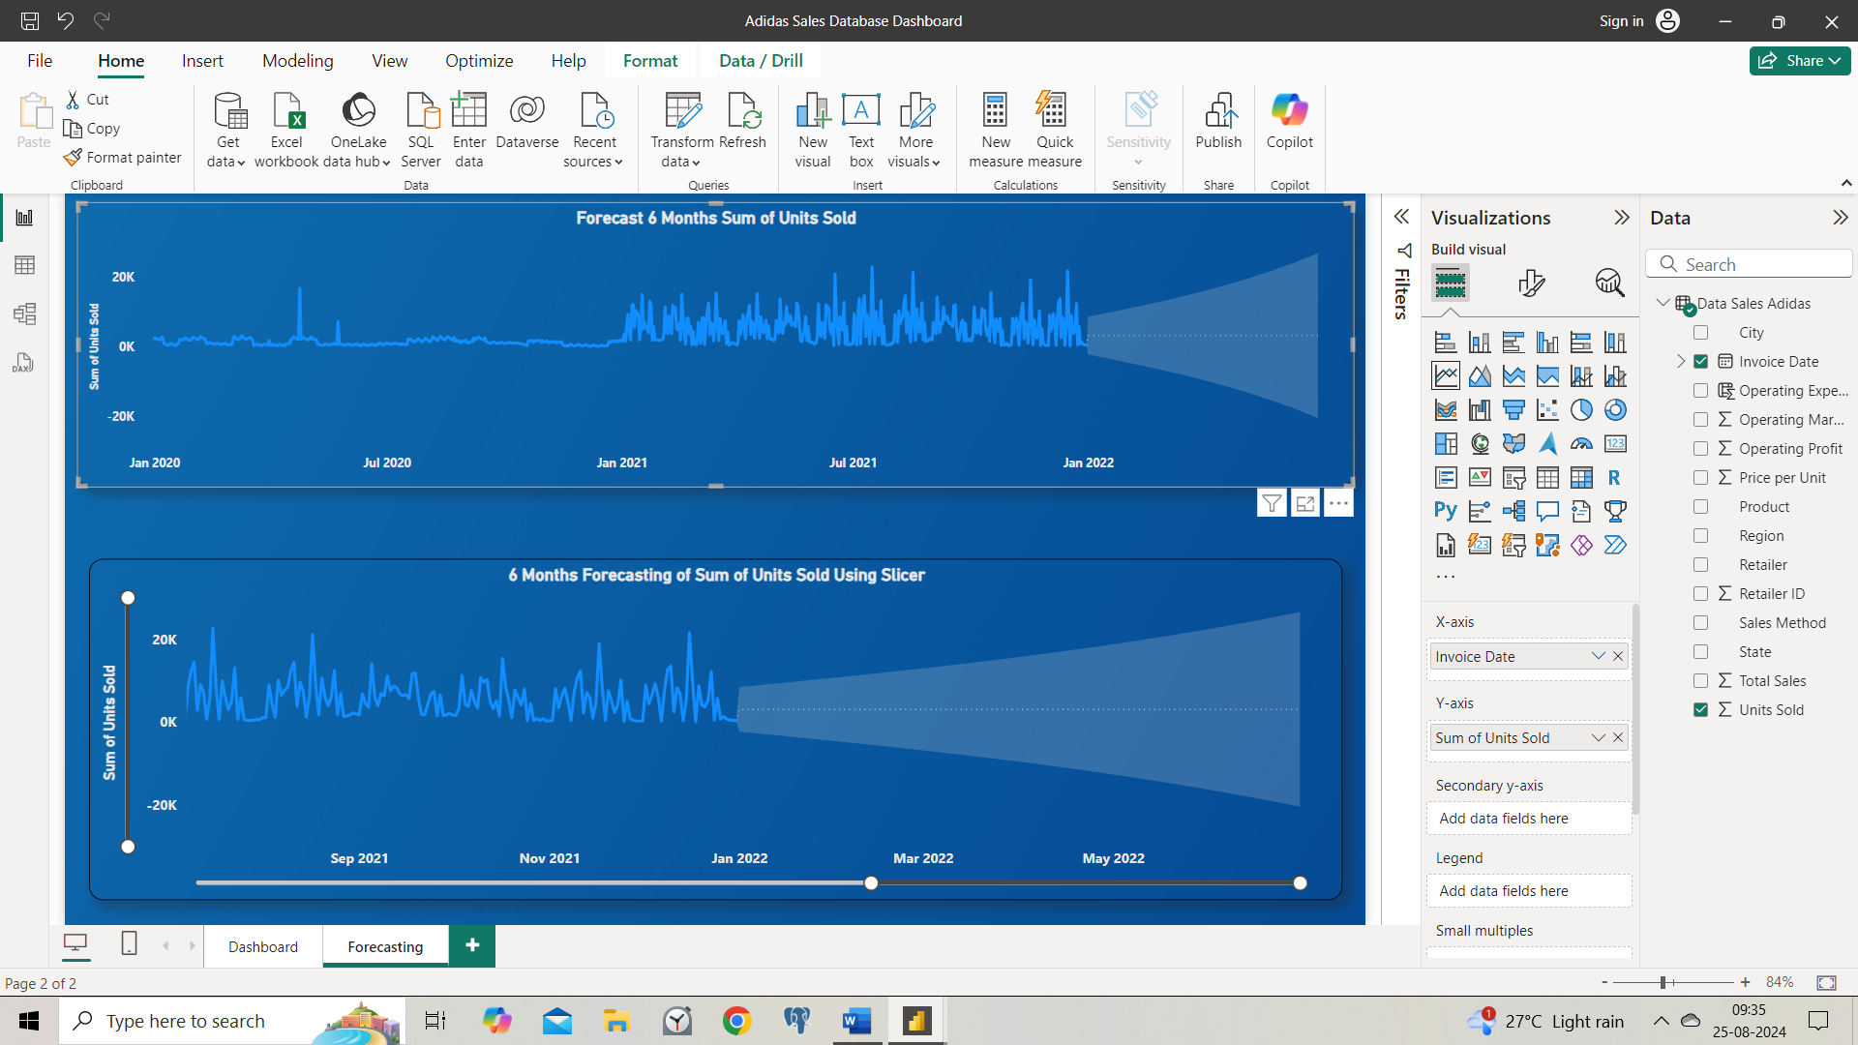

* **Conclusion:-**

**With the help of Dashboard we can easily analyse the data in which region, state or city through which way we need to work to improve sales.**